Chapter 21 Binary Search Trees

1. If a set of the same elements is inserted into a binary tree in two different orders, will the two corresponding binary trees look the same? No. Will the inorder traversal be the same? Yes. Will the postorder traversal be the same? No. Will the preorder traversal be the same? No.

2. The data fields must be initialized explicitly. Otherwise, their values are unpredictable.

- omitted

- inorder: 45 55 57 60 67 100 107
postorder: 45 57 55 67 107 100 60
preorder: 60 55 45 57 100 67 107
breadth-first: 60 55 100 45 57 67 107

5.

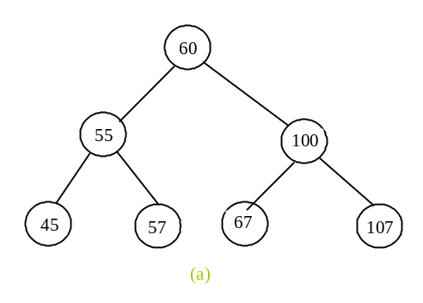

After removing 60
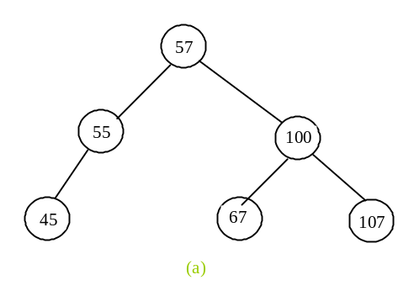
After removing 55
